Modelling Inequalities
Using Relational Rods

Algebra
Unit 2 Line Master 9

You can use relational rods to model and solve two-step inequalities involving whole numbers.
Here’s an example for the inequality 3r + 5 > 11.
- There is a “+ 5” in the expression on the left.
Start by placing a yellow 5 rod on a centimetre number line.
You want to add 3 rods of the same colour and end up to the
right of 11.
What colour rods can you use?
What is the smallest rod you can use?
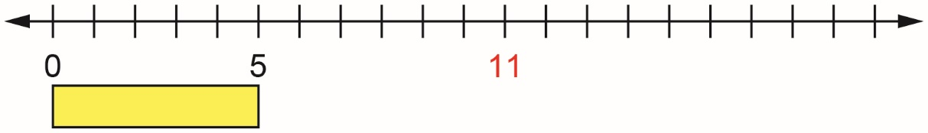

- The pink 4 rod works. You end up at 17.
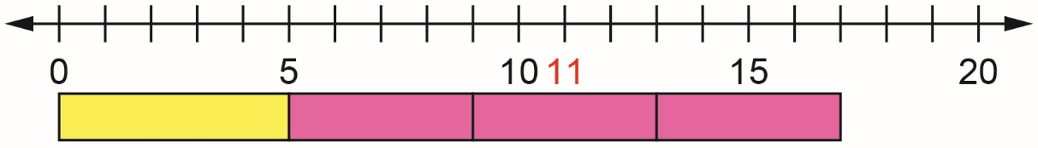

- The light green 3 rod also works. You end up at 14.
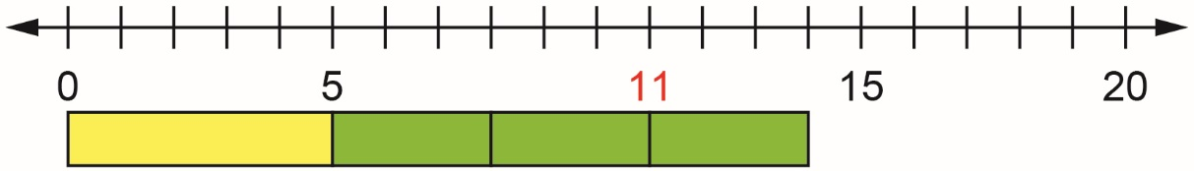

- But the red 2 rod doesn’t work. You end up at 11.
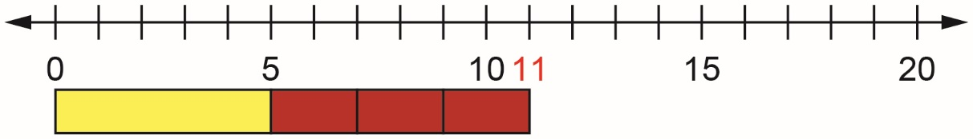

- The smallest rod that works is the light green rod.
So, the solution is r > 2.

