Graphing Inequalities

Algebra
Unit 2 Line Master 8a

Work with a partner.
Solve each inequality using any method you choose.
Graph each solution on the number line provided.
Show your work.
1. 3x + 4 > 37

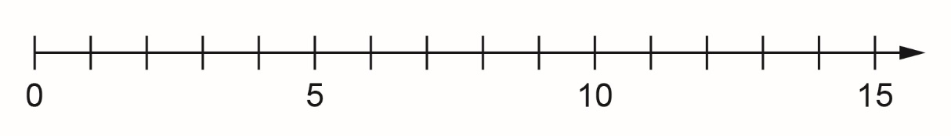
2. 17 ≥ 3p – 4

3. 23 – 5 < 7m – 5m

Graphing Inequalities (cont’d)

Algebra
Unit 2 Line Master 8b

4. n + 3n – 6 ≥ 42

5. 17 – 2s ≤ 3s + 2

