A-Maze-Ing Equations

Algebra
Unit 2 Line Master 6a

Find a path through the maze from A to J.
If you want to travel over a letter, you have to solve
the corresponding equation.
If a letter is not on your path, you don’t have to solve the equation!
Equations

A 50 – 14 = 3a

B 2.5b + 3 = 10.5

C $\frac{c}{3}$+ 4 = 8

D $\frac{d}{5}$– 4.8 = 7.2

E 10e + 7.8 = 25

F 8.2 + 10.6 = 2f

G 4.5g = 18.4 + 8.6

H 9.3 + 3.9 = 4.4h

I 3.2i – 5 = 20.6

J $\frac{j}{4}$+ 16.5 = 60
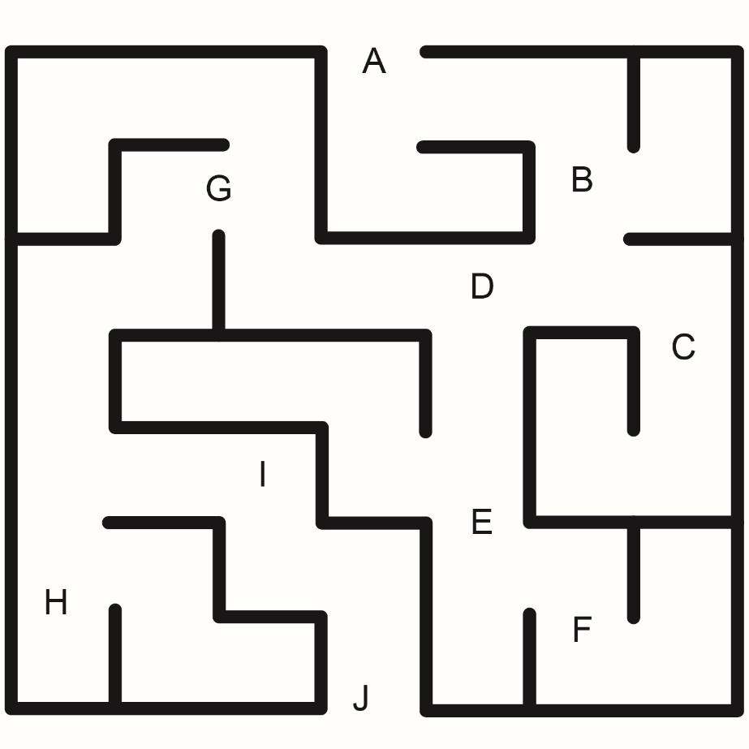

A-Maze-Ing Equations
(Accommodation)

Algebra
Unit 2 Line Master 6b

Find a path through the maze from A to J.
If you want to travel over a letter, you have to solve
the corresponding equation.
If a letter is not on your path, you don’t have to solve the equation!
Equations

A 50 – 26 = 3a

B 2b + 3 = 11

C $\frac{c}{3}$+ 4 = 8

D $\frac{d}{5}$– 4 = 7

E 10e + 5 = 35

F 8 + 10 = 2f

G 5g = 18 + 7

H 12 + 16 = 4h

I 3i – 5 = 22

J $\frac{j}{4}$+ 26 = 40

A-Maze-Ing Equations
(Create Your Own) (Extension)

Algebra
Unit 2 Line Master 6c

Find a path through the maze from A to J.
If you want to travel over a letter, you have to solve
the corresponding equation.
If a letter is not on your path, you don’t have to solve the equation!
Equations

A

B

C

D

E

F

G

H

I

J

