A-Maze-Ing Equations
Answers

Algebra
Unit 2 Line Master 6d

Find a path through the maze from A to J.
If you want to travel over a letter, you have to solve
the corresponding equation.
If a letter is not on your path, you don’t have to solve the equation!
Equations

A 50 – 14 = 3a
a = 12
B 2.5b + 3 = 10.5 = 3
b = 3
C $\frac{c}{3}$+ 4 = 8
c = $\frac{4}{3}$
D $\frac{d}{5}$– 4.8 = 7.2
d = 60
E 10e + 7.8 = 25
e = 1.72
F 8.2 + 10.6 = 2f
f = 9.4
G 4.5g = 18.4 + 8.6
g = 6
H 9.3 + 3.9 = 4.4h
h = 3
I 3.2i – 5 = 20.6
i = 8
J $\frac{j}{4}$+ 16.5 = 60
j = 174
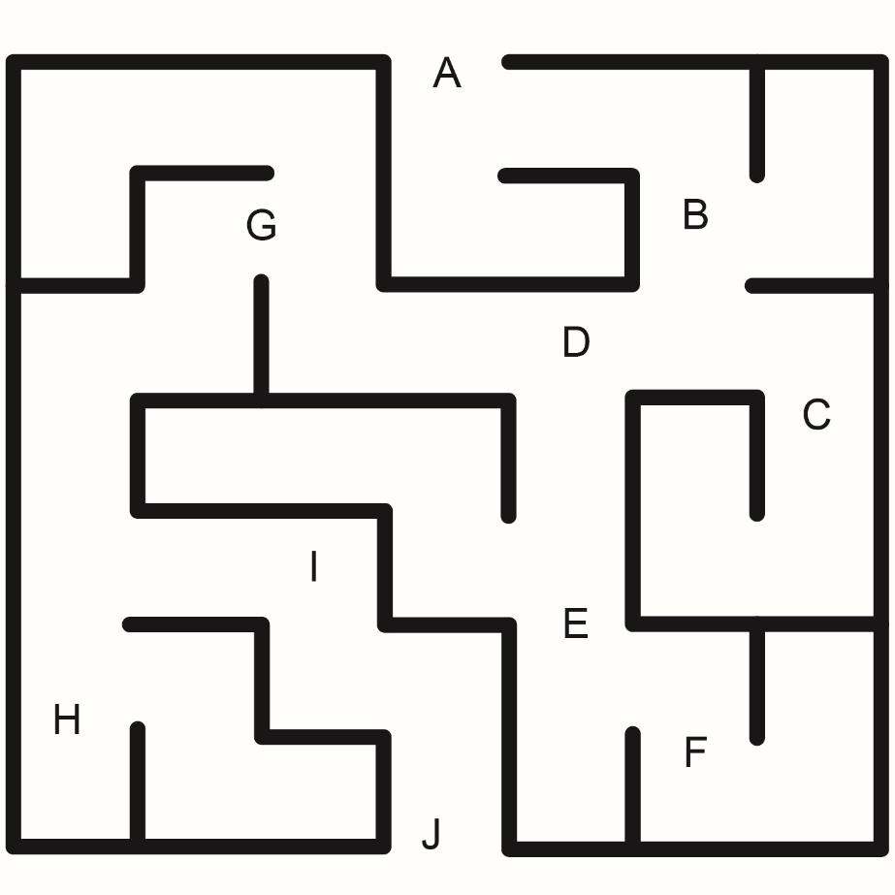

A-Maze-Ing Equations
(Accommodation)
Answers

Algebra
Unit 2 Line Master 6e

Find a path through the maze from A to J.
If you want to travel over a letter, you have to solve
the corresponding equation.
If a letter is not on your path, you don’t have to solve the equation!
Equations

A 50 – 26 = 3a
a = 8
B 2b + 3 = 11
b = 4
C $\frac{c}{3}$+ 4 = 8
c = 12
D $\frac{d}{5}$– 4 = 7
d = 55
E 10e + 5 = 35
e = 3
F 8 + 10 = 2f
f = 9
G 5g = 18 + 7
g = 5
H 12 + 16 = 4h
h = 7
I 3i – 5 = 22
i = 9
J $\frac{j}{4}$+ 26 = 40
j = 56

