Working with Linear Patterns
Determines missing terms in a pattern  Determine the numbers to complete this pattern.  85, 79, 73, ____, 61, ___  “Every term is 6 less than the previous term. So, I can find the missing terms by subtracting. The pattern is:  85, 79, 73, 67, 61, 55” | Uses a pattern rule to predict terms far ahead in a pattern  “The pattern rule is 3n + 1. To determine how many tiles would be in term 50, I substitute 50 for n.  3(50) + 1 = 150 + 1  = 151  There would be 151 tiles in term 50.” | Uses a pattern rule to determine the term number given a term value  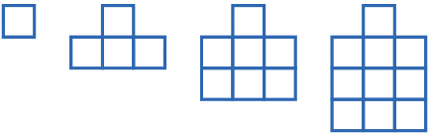  ”The pattern rule is 3n + 1. To determine which term has 100 tiles,  I need to find a value for n that makes 3n + 1 = 100.  I know that 3 $×$ 33 = 99, and 99 + 1 = 100. So, the answer is term 33.” | Creates and uses an algebraic pattern rule to model and solve  a problem  Maha pays $20 every month for a gym membership plus $3 for every class. If Maha pays $65 one month, how many classes did they attend?  “I can represent this with the expression 3n + 20 where n is the number of classes. I need to find a value for n so that  3n + 20 = 65. I’ll try n = 10.  3(10) + 20 = 30 + 20  = 50  This is too small. I’ll try n = 15.  3(15) + 20 = 45 + 20  = 65  Maha went to 15 classes that month.”
Observations/Documentation

