Comparing Linear Patterns
Represents linear patterns in different forms  “I can represent this linear pattern with a table of values, graph, or pattern rule. The pattern rule for this pattern is 2n + 1.” | Uses constant rate and initial value to match graphs and pattern rules  Which graph represents 2x and which represents 2x + 4?  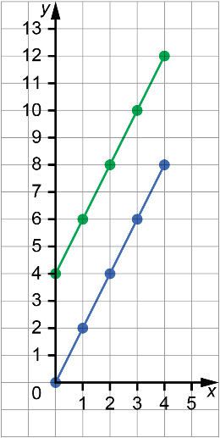  “I know the graph of 2x will begin at (0, 0) and the graph of 2x + 4 will begin at (0, 4). For both, every time you move right 1 you move up 2. The blue line represents 2x and the green line represents 2x + 4.” | Compares linear patterns by graphing them  Pattern A  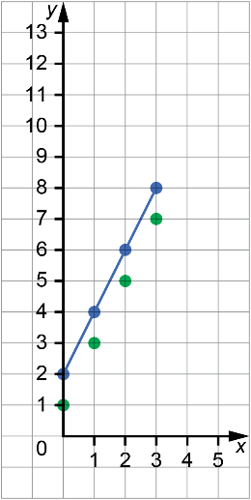  Pattern B: 2x + 2  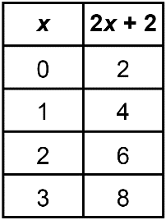  “I graphed both patterns.  They have different initial values but the same constant rate, 2. Pattern A is a series of points, the points in Pattern B can be joined with a line.” | Predicts how changes to an expression will affect its graph  This graph shows the pattern 2x + 2.  How will the graph of 2x + 4 compare to this? How will the graph of 5x + 2 compare?  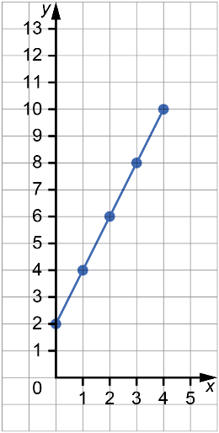  “The graph of 2x + 4 will look just like this but shifted up 2 units.  The graph of 5x + 2 will start at the same point but be much steeper.”

Observations/Documentation

