Writing an Expression to Describe a Linear Pattern
Represents a linear pattern in a table and by describing it in words  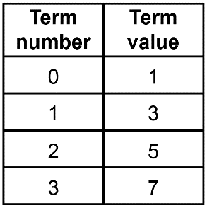  “There are 2 more circles each time and term 0 is 1. If I know the term number, I can find the number of circles by multiplying by 2, then adding 1.” | Writes an algebraic expression to describe a linear pattern  “I let n represent the term number. Then the term value can be described as 2n + 1.” | Writes a pattern rule for a given set of conditions and represents it in different ways  Create a pattern rule, table of values, and visual representation of a pattern with an initial value of 1 and a constant rate of 3.  “The pattern rule is 3n + 1.  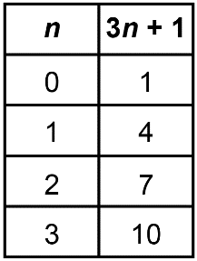  I made a pattern of square tiles to represent this relationship.”  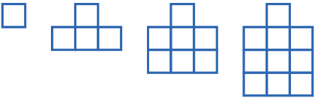 | Writes an algebraic pattern rule to model a real-life situation  Mitchell practises for a swim meet. They swim 10 laps on Monday.  Each day for the rest of the week, they increase the number of laps they swim by 5.  The pattern is 10, 15, 20, 25,...  I can represent this with the expression 5n + 5 where n is the number of days Mitchell swims.

Observations/Documentation

