Answers
Answers
Algebra
Unit 1 Line Master 5e

1. a) Each expression represents a linear pattern.
For each pattern, complete the table of values.
A: 2x + 2 B: 3x + 2
x | 2x + 2
0 | 2
1 | 4
2 | 6
3 | 8
x | 3x + 2
0 | 2
1 | 5
2 | 8
3 | 11

C: 4x + 2
x | 4x + 2
0 | 2
1 | 6
2 | 10
3 | 14

Answers (cont’d)
Answers
Algebra
Unit 1 Line Master 5f

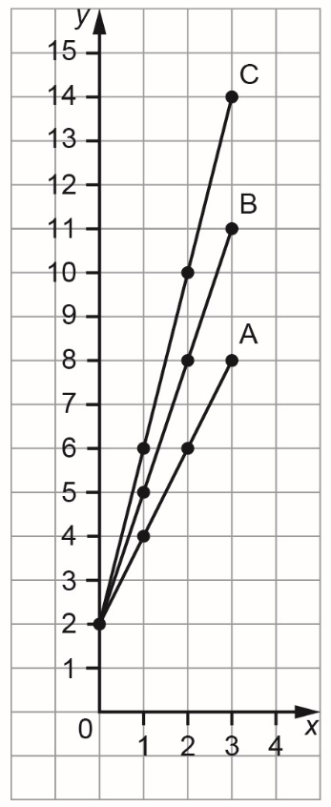
b) Graph each pattern on the grid
provided. Join each set of points
with a line.

c) How do the expressions compare?
How do the lines on the graph
compare?
The expressions have the same
constant term, 2, but different
coefficients of x.
Each graph starts at the point
(0, 2) and the points move up
as you move right.
The constant term tells you
the initial value.
The steepness of each line
is different.
Pattern C has the steepest line.
For A: every time x increases
by 1, y increases by 2.
For B: every time x increases
by 1, y increases by 3.
For C: every time x increases
by 1, y increases by 4.
The coefficient of x tells you
the constant change.

Answers (cont’d)
Answers
Algebra
Unit 1 Line Master 5g

2. a) Each expression represents a linear pattern.
For each pattern, complete the table of values.
A: 3x + 1 B: 3x + 3
x | 3x + 1
0 | 1
1 | 4
2 | 7
3 | 10
x | 3x + 3
0 | 3
1 | 6
2 | 9
3 | 12

C: 3x + 5
x | 3x + 5
0 | 5
1 | 8
2 | 11
3 | 14

Answers (cont’d)
Answers
Algebra
Unit 1 Line Master 5h

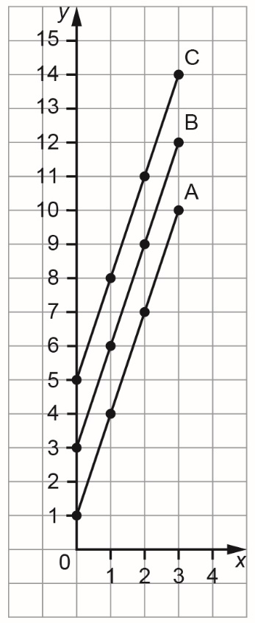
b) Graph each pattern on the grid
provided. Join each set of points
with a line.

c) How do the expressions compare?
How do the lines on the graph
compare?
The expressions have the same
coefficient of x, 3, but different
constant terms.
Each line starts at a different
point on the vertical axis.
The constant term tells you
the initial value.
The points on each graph move
up as you move right.
Every time x increases
by 1, y increases by 3.
The lines all have the same
steepness.
They are parallel.
The coefficient of x tells you
the constant change.

