Writing and Solving Problems Involving Linear Relations
Represents a linear expression or equation by constructing a table of values and drawing a graph  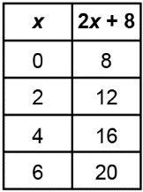  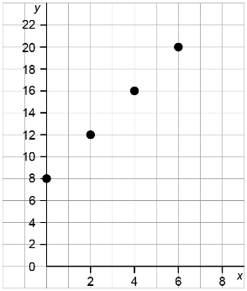 | Interprets a linear expression or equation by describing a situation it could be used to model  For the expression 2x + 8, I let 8 represent the entrance cost, in dollars, to a fair.  I let x represent the number of rides a person goes on, and 2 represent the cost, in dollars, of each ride.  The expression 2x + 8 is the total cost to go to the fair and go on some rides. | Solves problems related to a situation that can be modelled by  a linear expression or equation that is provided  If I know that a person spent $30 at the fair, I can write the equation 30 = 2x + 8 and use it to determine how many rides they went on.  30 = 2x + 8  Subtract 8 from each side.  30 – 8 = 2x + 8 – 8  22 = 2x  Divide both sides by 2.  $\frac{22}{2}$= $\frac{2x}{2}$  11 = x  The person went on 11 rides. | Writes a linear expression or equation to represent a given situation and uses it to solve problems  For every 3 books participants read in the summer reading program, they get a ticket for a draw. If Nahlah gets 8 tickets, how many books did they read?  Solution:  I let the number of books read be b. To determine the number of tickets, divide the number of books by 3.  If Nahlah gets 8 tickets, I can write  the equation 8 = $\frac{b}{3}$.  Multiply both sides by 3.  8 × 3 = $\frac{b}{3}$× 3  24 = b  Nahlah read 24 books.
Observations/Documentation

