Modelling and Solving Multi-Step Linear Equations
Creates an equation involving two operations  I started with the equation x = 6.  I multiplied both sides by 3.  3x = 18  Then, I subtracted 5 from each side.  3x – 5 = 13 | Solves a multi-step equation involving whole numbers using concrete materials or informal solution methods  I used algebra tiles to solve  3x – 5 = 13.  I added 5 yellow 1-tiles to each side.  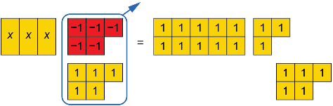  I removed zero pairs.  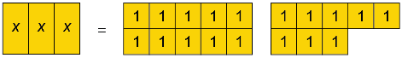  I arranged the tiles in 3 equal groups.  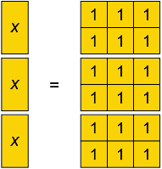  x = 6 | Solves multi-step equations involving whole numbers symbolically  3x – 5 = 13  3x – 5 + 5 = 13 + 5  3x = 18  $\frac{3x}{3}$= $\frac{18}{3}$  x = 6 | Verifies the answer to a multi-step equation is correct  To check if my answer is correct,  I substituted the number I got for x  in the original equation and compared each side.  L.S. = 3x – 5  = 3(6) – 5  = 18 – 5  = 13  R.S. = 13  The answer is correct.
Observations/Documentation

