Writing an Expression to Describe a Linear Pattern
Constructs a table of values to represent a linear pattern and describes the pattern in words  There are 2 more circles each time. If I know the term number, I can find the number of circles by multiplying by 2, then subtracting 1. | Writes an algebraic expression to describe a linear pattern  I let n represent the term number. Then the term value can be described as 2n – 1. | Writes an algebraic expression that matches a given set of conditions and represents it in a variety of ways  Write an expression with variable n, coefficient 3, and constant term –2.  My expression: 3n – 2  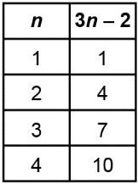  I made a pattern of square tiles to represent this relationship.  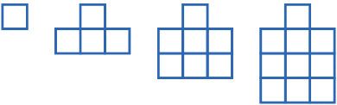 | Uses an algebraic expression to model a real-life situation  Mitchell practises for a swim meet. They swim 10 laps on Monday.  Each day for the rest of the week, they increase the number of laps they swim by 5.  The pattern is:  5, 10, 15, 20, 25, 30, 35  I can represent this with the expression 5n + 5.
Observations/Documentation

