Patterning and Algebra
Unit 1 Line Master 10a
What’s your Story?

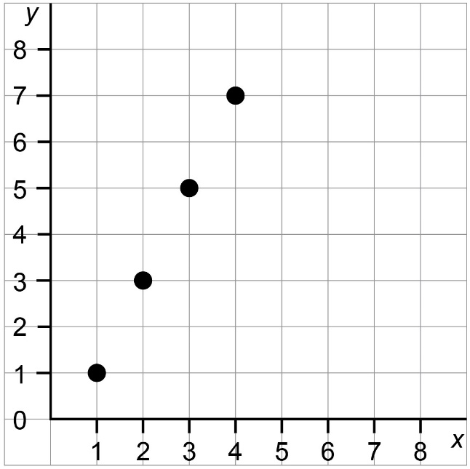
1. Create a story about the graph.

2. What do the x- and y-variables represent in your story?
Label the axes to show what they represent.

3. Write an equation to represent the graph.

Patterning and Algebra
Unit 1 Line Master 10b
What’s your Story? (cont’d)

4. Create and solve two problems about the scenario you described.
- One that can be answered by determining an x-value.
- One that can be answered by determining a y-value.

