Which Is the Better Deal?
Number
Unit 5 Line Master 4

Two stores are offering a discount on the same headphones.

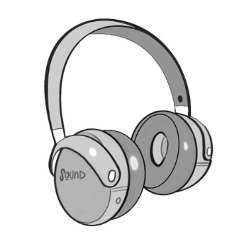

Store A | Store B
Regular price: $79.99  On sale for 25% off | Regular price: $89.99  On sale for 35% off

Would you rather buy the headphones from Store A or Store B?
Justify your answer.

