How Much Sales Tax Do You Pay?
Number
Unit 5 Line Master 3

Here is a receipt for a grocery store.

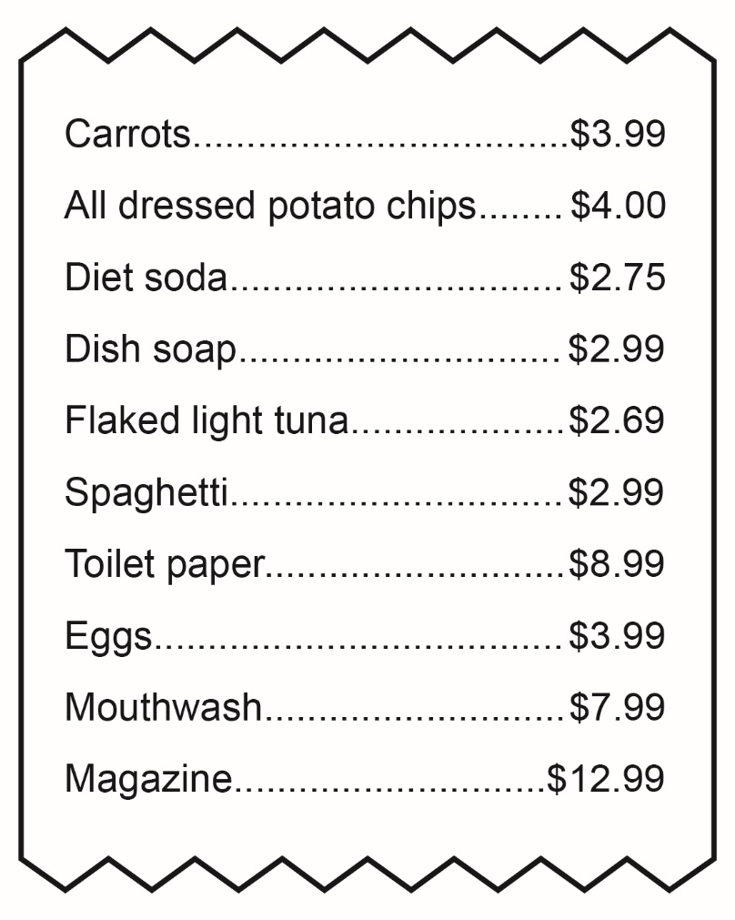

What is the total cost including sales tax(es)?

