Venn Diagrams

**Number**

**Unit 5 Line Master 2a**

**Venn** **Diagram 1**

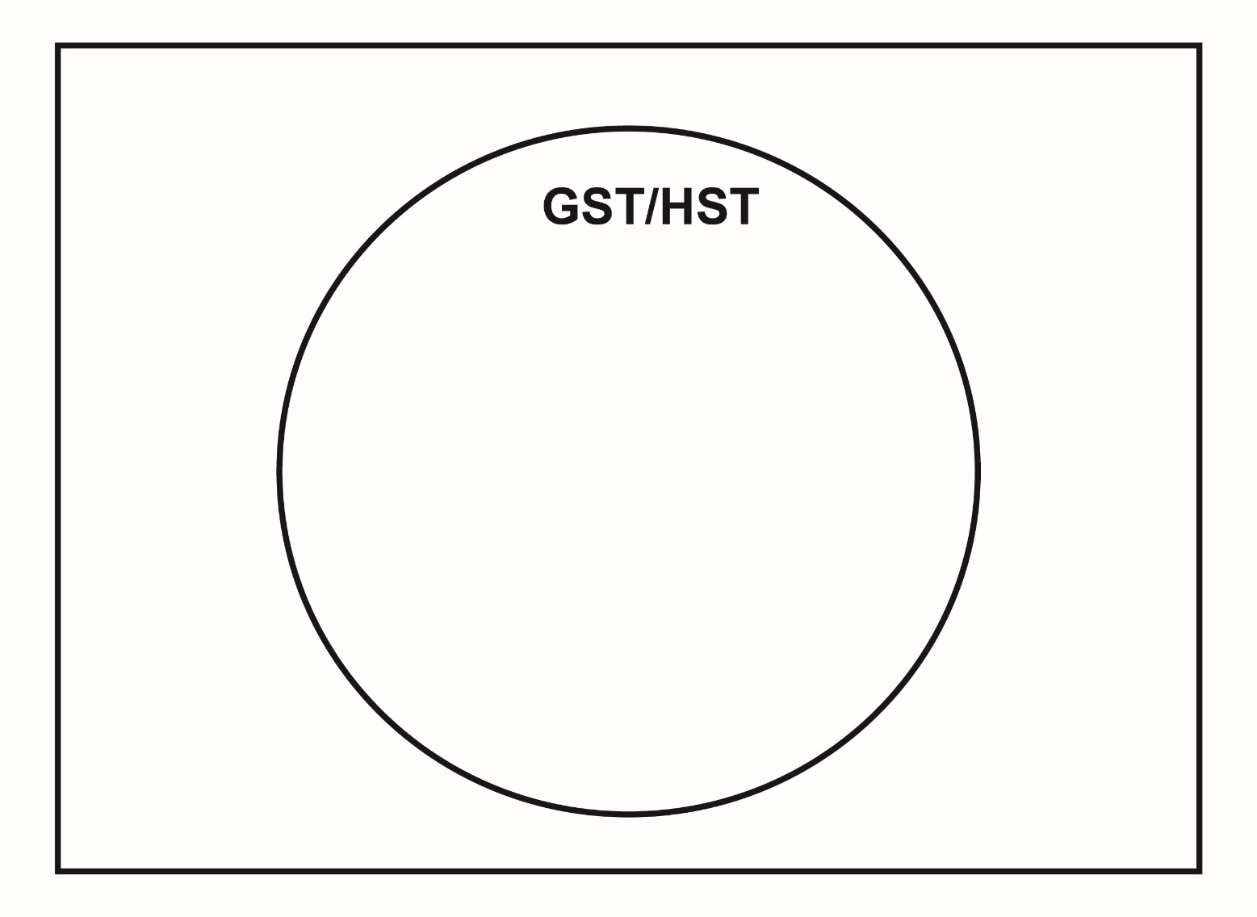

**Number**

**Unit 5 Line Master 2b**

Venn Diagrams (cont’d)

**Venn Diagram 2**

