Working with Percents
Determines a part given its percent and the whole  25% of $60 is ___.  I used a number line.  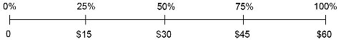  25% of $60 is $15. | Determines a percent given its quantity and the whole  ___% of 75 is 30.  I used benchmarks and mental math.  100% is 75.  10% is 7.5.  Since 4 × 7.5 = 30, 40% of 75 is 30. | Determines a whole given a quantity and its percent  75% of ___ is 30  I used equivalent fractions.  $\frac{75}{100}$÷ $\frac{5}{5}$= $\frac{15}{20}$  $\frac{15}{20}$× $\frac{2}{2}$= $\frac{30}{40}$  So, the whole is 40.  75% of 40 is 30. | Solves a problem involving percents from 1% to 100%  In a survey, 250 people were asked which is their favourite fruit.  35 people said bananas.  What percent of people said bananas?  “I can use a number line.”  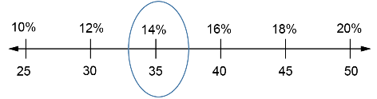  10% of 250 is 25.​  20% of 250 is 50.​  14% of 250 is 35.​  So, 14% of people said bananas were their favourite fruit.
Observations/Documentation

