Dividing Decimals
Uses whole number strategies  to estimate a quotient  13.2 ÷ 2.4  13.2 is about 10 and 2.4 is about 2, and 10 ÷ 2 is 5. So, the quotient  is close to 5. | Uses concrete or pictorial strategies to divide decimals  2.16 ÷ 0.8 = ?  I used an area model with a width  of 0.8 to create an area of 2.16.  The length of the area is the quotient, 2.7.  I checked my answer using multiplication:  2 × 0.8 = 1.6  0.7 × 0.8 = 0.56  2.7 × 0.8 = 2.16 | Uses a variety of strategies  to divide decimals  1.95 ÷ 0.3 = ?  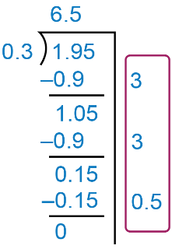 | Uses an appropriate strategy or tool to solve problems  If a landscaper is paid $21.50/h,  how many hours did the landscaper work to earn $118.25?  My estimate is 120 ÷ 20 = 6.  I used a calculator and got 5.5.  So, the landscaper worked 5.5 h.
Observations/Documentation

