Multiplying Decimals
Uses whole number strategies  to estimate a product  8.3 × 2.4  8.3 is about 8 and 2.4 is about 2, and 8 × 2 is 16. So, the product  is close to 16. | Uses whole number strategies  to multiply decimals  2.2 × 2.6 = ?  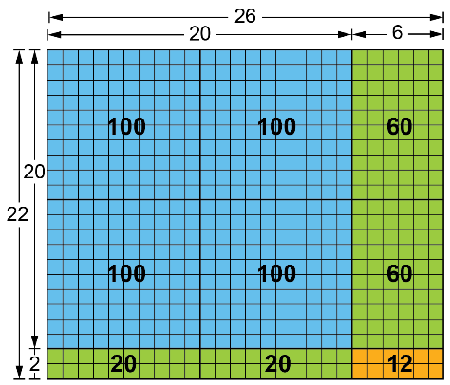  I used an array on a grid to show  an area model.  26 × 22  = 400 + 40 + 120 + 12  = 572  My estimate was 6, so 2.2 × 2.6 must be 5.72. | Uses estimation to check that the answer to a decimal multiplication problem is reasonable  2.2 × 2.6 = ?  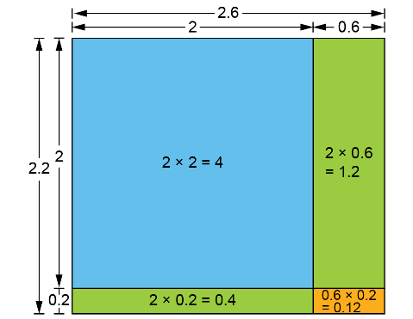  2.6 × 2.2  = 4 + 0.4 + 1.2 + 0.12  = 5.72  My estimate was 6.  Since 5.72 is close to 6, the answer is reasonable. | Uses an appropriate strategy or tool to multiply decimals  If rice costs $3.69/kg, how much would 1.25 kg of rice costs?  I used a calculator and got 4.6125. Rounding to the nearest cent, the rice would cost $4.61.
Observations/Documentation

