Representing Fractional Percents
Writes a fraction as a fractional percent  $\frac{3}{8}$ = 0.375 × 100%  = 37.5%, or 37$\frac{1}{2}$%  $\frac{4}{9}$ = 0.444… × 100%  = $44.\overline{4}$% | Represents a fractional percent on a hundredths grid  For 37.5%, or 37$\frac{1}{2}$%:  $\frac{1}{2}$% is one-half of 1%, so $\frac{1}{2}$% is one-half of a square on a hundredths grid.  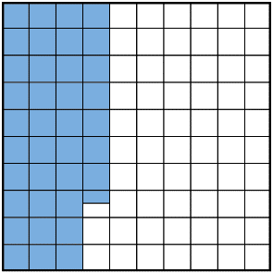 | Determines a fractional percent of a number  What is 15$\frac{1}{4}$% of 80?  10% of 80 = 8  5% of 80 = 4  1% of 80 = 8 ÷ 10 = 0.8  $\frac{1}{4}$% of 80 = 0.8 ÷ 4 = 0.2  So, 15$\frac{1}{4}$% of 80 = 8 + 4 + 0.2  = 12.2 | Solves a problem involving a fractional percent  A real-estate agent sells a home for $650 000.  The commission is 2$\frac{1}{2}$%.  How much does the agent earn on this sale?  1% of $650 000  = $650 000 ÷ 100  = $6500  So, 2% = 2 × $6500  = $13 000  $\frac{1}{2}$% = $6500 ÷ 2  = $3250  Commission:  $13 000 + $3250 = $16 250
Observations/Documentation

