Dividing Integers
Relates multiplication and division of positive integers  Make 12 using two positive factors and write the related division facts.  2 × 6 = 12  12 ÷ 6 = 2  12 ÷ 2 = 6  “If 2 times 6 is 12, then 12 divided  by 2 is 6.” | Relates multiplication and division of negative integers  Make 12 using two negative factors and write the related division facts.  –2 × (–6) = 12  12 ÷ (–6) = –2  12 ÷ (–2) = –6  “When the two factors are negative, the quotient is negative.” | Relates multiplication and division of integers with opposite signs  Make –12 using two factors and write the related division facts.  2 × (–6) = –12  –12 ÷ (–6) = 2  –12 ÷ 2 = –6  “When the product is negative,  the quotient may be positive  or negative.” | Generalizes and applies the rules for dividing integers  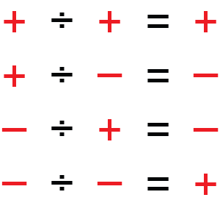  “When the dividend and divisor  have the same sign, the quotient  is always positive.”
Observations/Documentation

