Multiplying Integers
Uses repeated addition to model integer multiplication concretely and pictorially  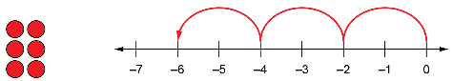  “–2 + (–2) + (–2) = –6  3 × (–2) is 3 groups of –2.  3 × (–2) = –6” | Uses number properties to multiply integers with opposite signs  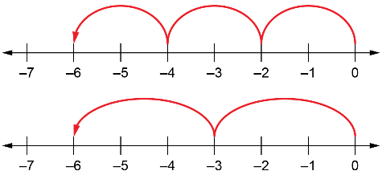  “3 groups of –2 and 2 groups  of –3 are the same,  so 2 × (–3) = 3 × (–2).” | Uses a pattern to multiply two negative integers  3 × (–3) = –9  2 × (–3) = –6  1 × (–3) = –3  0 × (–3) = 0  –1 × (–3) = 3  –2 × (–3) = 6  “The pattern is ‘Add 3 each time.’ The product of two negative integers is positive.” | Generalizes the sign rules for integer multiplication  3 × 9 = 27  3 × (–9) = –27  –3 × 9 = –27  –3 × (–9) = 27  “The product of two integers is positive when the integers have the same sign, and negative when they do not.”
Observations/Documentation

