Solving Problems Involving Integers
Uses integers to represent real-life situations  A beluga whale was swimming at a depth of 15 m. It dove down another 180 m to feed. At what depth was the whale feeding?  “The two depths are below the surface. If the surface of the ocean is 0 m, the depths are  –15 m and –180 m.” | Writes expressions to represent problem situations involving integers  –15 + (–180)  “I need to find the whale’s feeding depth. The whale starts at  –15 m and dives down –180 m farther, so I need to add.” | Selects effective problem-solving strategies (including models)  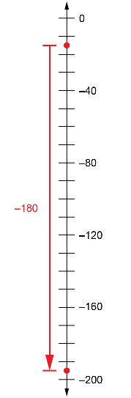  –15 + (–180) = –195  “180 is a lot of counters to count.  I’ll use a number line.” | Solves problems involving integers in more than one way  “I can also just add 15 m  and 180 m to determine  the feeding depth.”
Observations/Documentation

