**Number**

**Unit 2 Line Master 1a**

Number Lines 1

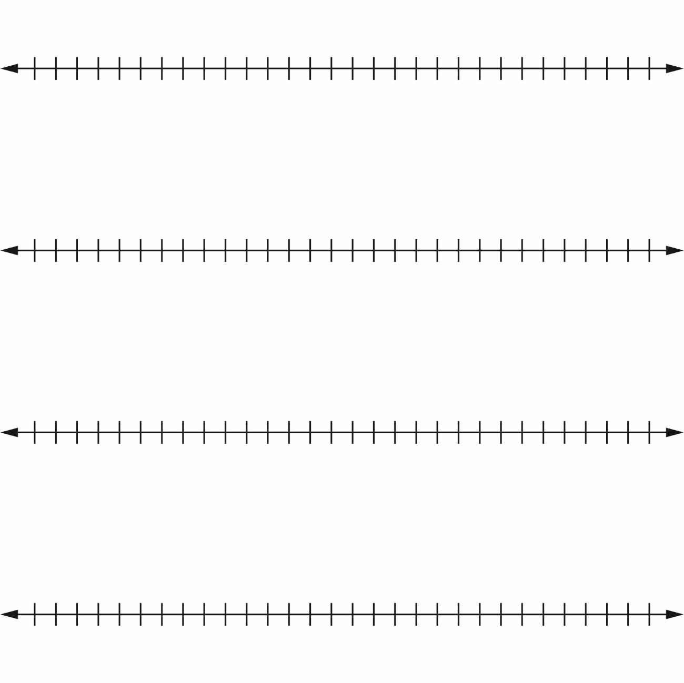

**Number**

**Unit 2 Line Master 1b**

Number Lines 2

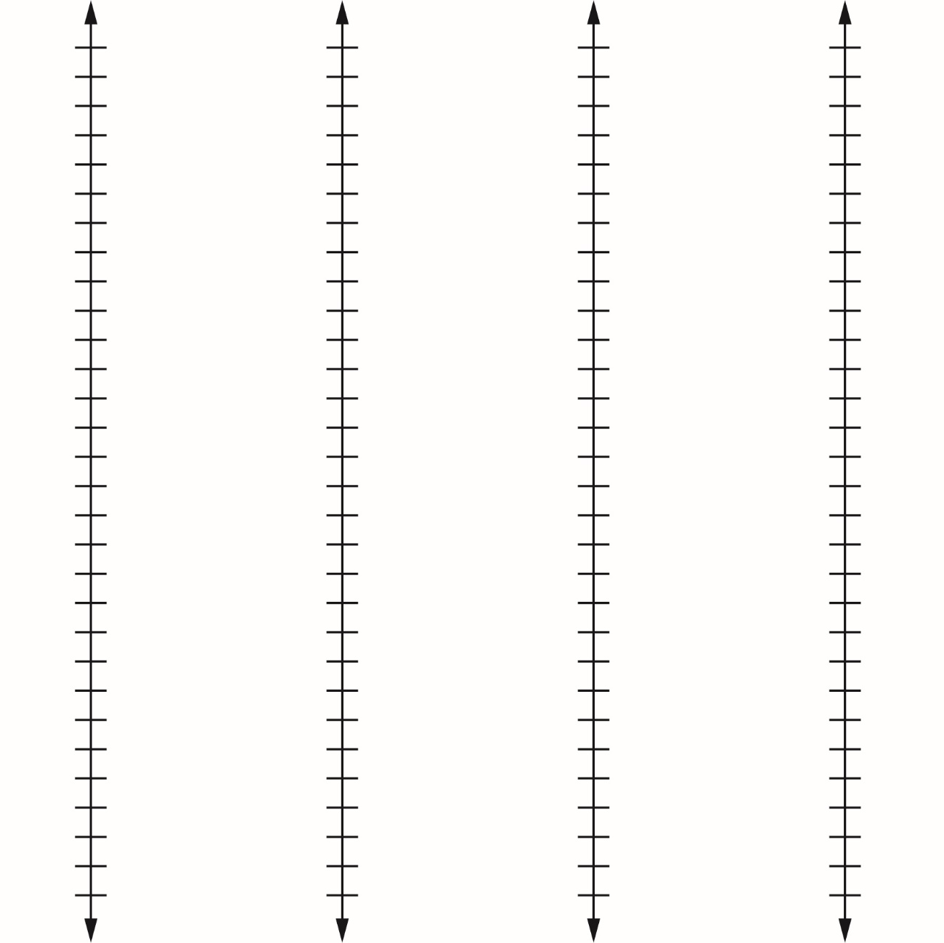

**Number**

**Unit 2 Line Master 1c**

Number Lines 3

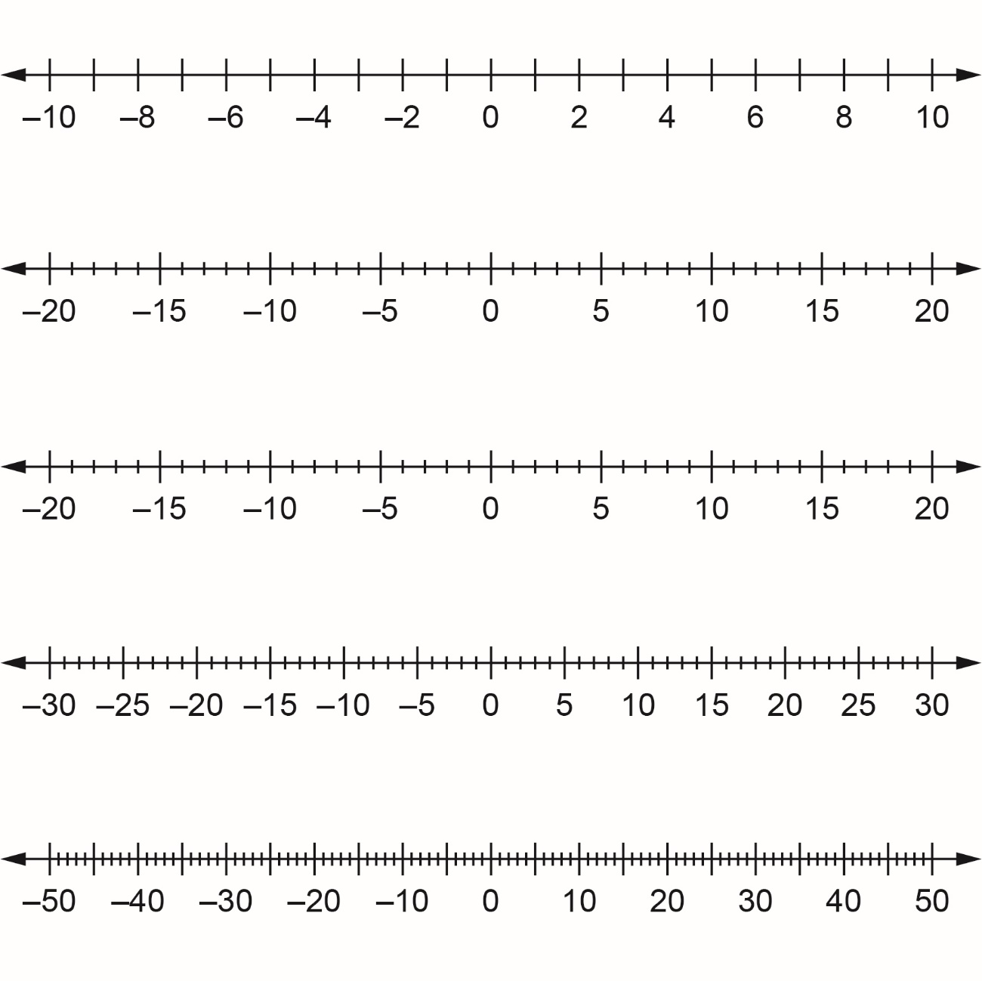

**Number**

**Unit 2 Line Master 1d**

Number Lines 4

