Number
Unit 1 Line Master 4a
Numbers Divisible by 3 and by 6

1. a) Shade all multiples of 3.

b) What do you notice about the sum of the digits in the numbers
that you shaded?

c) Write a divisibility rule for 3.

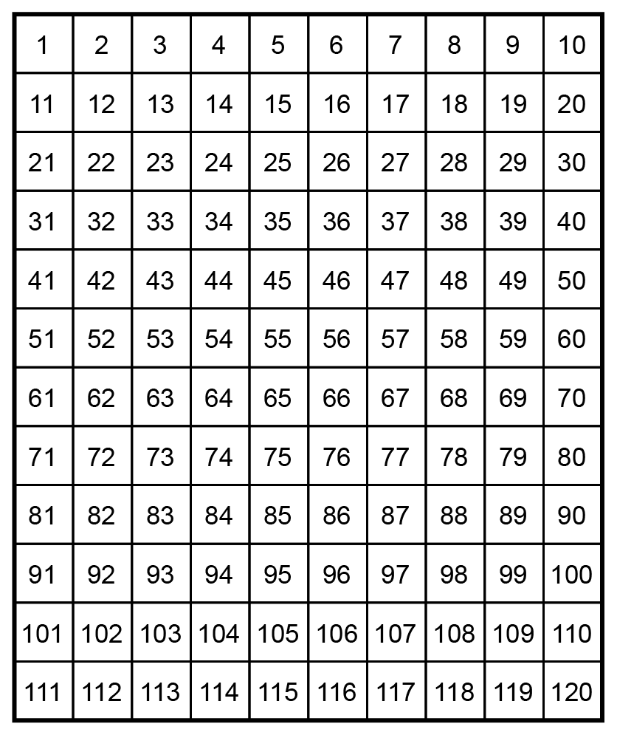

Number
Unit 1 Line Master 4b
Numbers Divisible by 3 and by 6 (cont’d)

2. Sort the numbers from 1 to 30 in the Venn diagram.
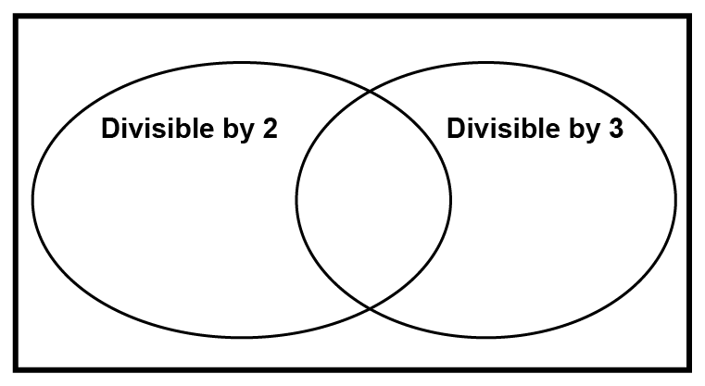
- What do you notice about all the numbers in the overlap
of the Venn diagram?

- What number are all these numbers divisible by?

- Write a divisibility rule that is true for all these numbers.

