Number
Unit 1 Line Master 1
Check and Save!

Sort these numbers in the Venn diagram:
24 4 15 112 36 1040 364
8026 4444 6 32 63
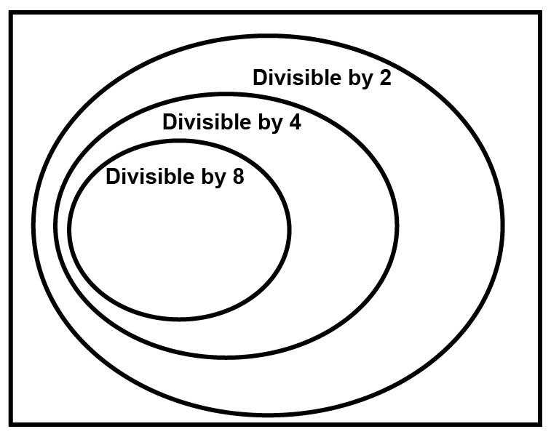
Look at your completed Venn diagram.
What is a divisibility rule for 8?

