Determining the Volume of Rectangular Prisms and Cylinders
Understands that volume is a measure of the space filled by  an object  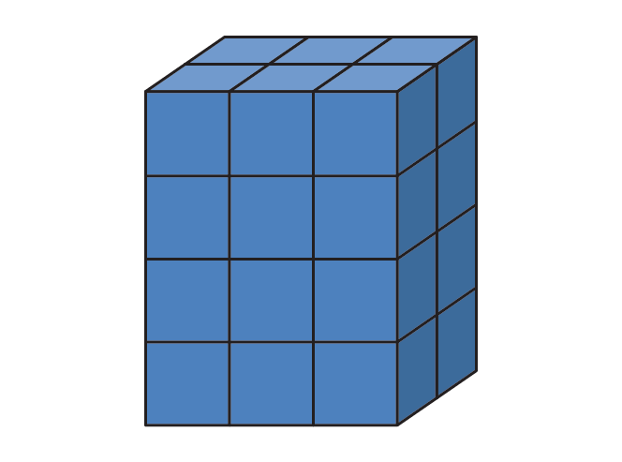  The volume of the prism is  24 unit cubes. | Understands that the volume of a rectangular prism is the product of the area of its base and its height  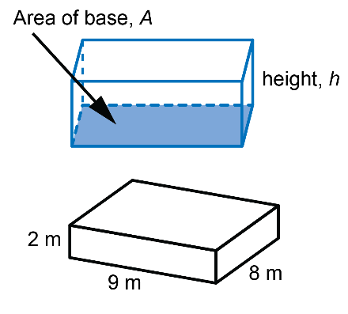  area of the base: 9 × 8 = 72  The area of the base is 72 m².  area of base × height: 72 × 2 = 144  The volume of the box is 144 m³. | Determines the volume of a cylinder  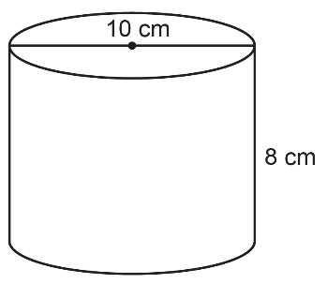  area of base:  π × r² ≈ 3.14 × 5²  = 78.5  The area of the base is  about 78.5 cm².  Volume:  A × h ≈ 78.5 × 8  = 628  The volume is about 628 cm³. | Determines a missing measurement when given the other measurements  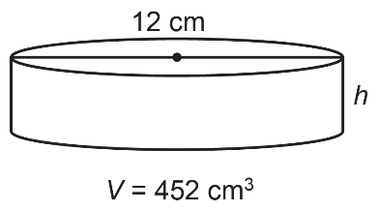  What is the approximate height  of the cylinder?  Volume:  V = πr²h  452 ≈ 3.14 × 6² × h  452 = 113.04 × h  h = 452 ÷ 113.04  h ≈ 4  The height is about 4 cm.
Observations/Documentation

