Constructing Bisectors
Describes examples of perpendicular and angle bisectors in the environment  For example, a perpendicular bisector divides a granola bar into two equal parts and an angle bisector divides a slice of pizza into two equal parts. | Explains how to identify perpendicular and angle bisectors  I can measure the two parts of the line segment to check they are equal, and measure the angles at the intersection to check each is 90°.  I can measure the two angles formed by the bisector. They should be equal. | Constructs perpendicular and angle bisectors  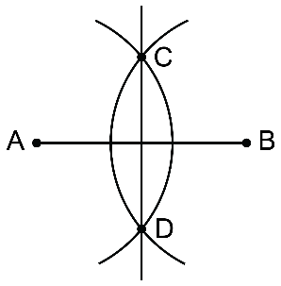  I drew line segment AB. Using a compass setting greater than one-half the length of AB, I drew arcs from A and B. Then I used a ruler to join the two points where the arcs intersected to create the perpendicular bisector. | Solves problems involving perpendicular and angle bisectors  How can you use perpendicular bisectors to draw a rhombus?  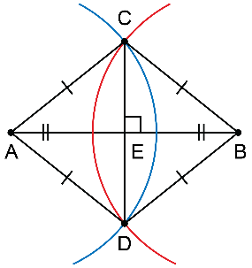  The diagonals of a rhombus are perpendicular bisectors of each other. I drew line segment AB.  Next, I used a compass to draw the perpendicular bisector CD.  Then, I drew AC, CB, BD, and DA.
Observations/Documentation

