Constructing Lines
Describes examples of parallel and perpendicular line segments in the environment  For example, the horizontal shelves of a bookcase from parallel line segments and the vertical sides of the bookcase form perpendicular line segments with the shelves. | Explains how to identify parallel and perpendicular line segments  I can measure the distance between the line segments at each end. If it is the same, I know the lines are parallel.  I can measure the angles at the intersection. For perpendicular line segments, the angles are 90°. | Constructs parallel and perpendicular line segments  To draw parallel line segments, I drew line segment AB. I put my protractor on AB and made a dot at both 45° marks. Then I used a ruler to join the two points. | Solves problems involving parallel and perpendicular line segments  Draw parallelogram ADEC.  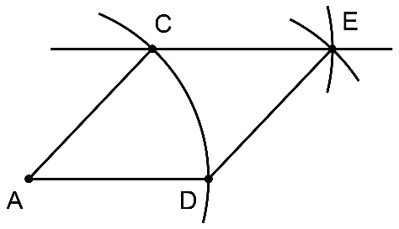  I drew line segment AD. Next, I placed the compass point at A to draw an arc with radius AD intersecting the line segment at D.  Then, I chose point C along the arc. Using the same compass setting,  I drew arcs from C and D intersecting at point E.  Finally, I drew CE, AC, and DE.
Observations/Documentation

