Determining the Area of Triangles and Parallelograms
Explains the relationships between the area of a rectangle and a triangle  I drew a diagonal of the rectangle and divided the rectangle in two equal triangles.  Area rectangle = 50 cm²  Area triangle = 25 cm²  So, the area of a triangle is one-half the area of a rectangle.  A = b × h ÷ 2  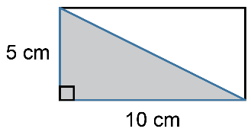 | Uses triangle area formula to determine a missing measure  What is the base of a triangle with area of 36 cm² and height of 6 cm?  I used the area formula for a triangle.  A = $\frac{1}{2}$bh  36 = $\frac{1}{2}$ × b × 6  36 = 3 × b  $\frac{36}{3}$ = b  b = 12  The base of the triangle is 12 cm. | Explains the relationships between the area of a rectangle and a parallelogram  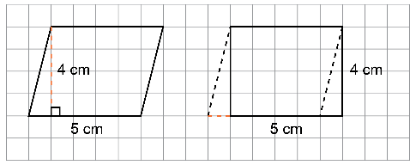  I cut a triangle from end of the parallelogram and moved it to the other end.  The area of the parallelogram was rearranged to form a rectangle, and no area was lost. So, the area of a parallelogram is the same as the area of a rectangle, 20 cm².  A = b × h | Uses parallelogram area formula to determine a missing measure  What is the base of a parallelogram with area of 36 cm² and height of  6 cm?  A = bh  36 = b × 6  $\frac{36}{6}$ = b  b = 6  The base of the parallelogram  is 6 cm.
Observations/Documentation

