Exploring Central Angles
Identifies a central angle  Central angles are formed when two radii meet at the center of the circle.  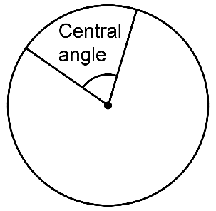 | Identifies major and minor arcs  An arc is named by the related central angle measure.  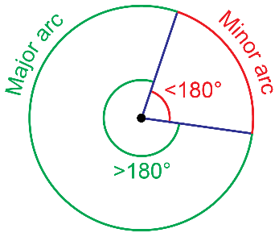 | Understands that the sum of the central angles of a circle is 360°  A diameter has a central angle measure of 180° on both sides.  180° + 180° = 360°  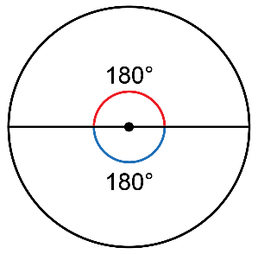 | Uses sum of the central angles of  a circle to solve problems  Determine the measure of the missing angle.  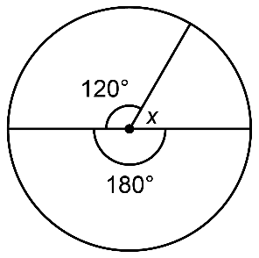  360° – 120° – 180° = 60°
Observations/Documentation

