Exploring Circles
Understands the relationship between radius and diameter  of a circle  If the diameter of a circle is 12 cm, what is its radius?  Since the diameter is double the radius, then the radius is 12 ÷ 2,  or 6 cm. | Understands relationships between radius, diameter, and circumference of a circle  If the radius of a circle is 6 cm, what is its circumference?  I know that the circumference of a circle is about “6 and a bit” times its radius.  So, the circumference is “6 and a bit” × 6,  or about 37 cm. | Constructs circles given the radius, diameter, or circumference  Draw a circle with a diameter of  12 cm.  The radius is 12 ÷ 2, or 6 cm. I used a ruler to set the compass to 6 cm. Then, drew the circle.  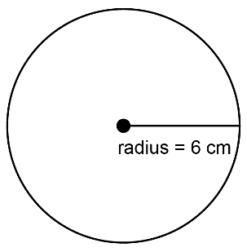 | Uses relationships between circle measures to solve problems  Determine the circumference of a pizza with a diameter of 30 cm.  I used the relationship  circumference = diameter × “3 and  a bit” to get a circumference of approximately 91 cm.
Observations/Documentation

