Measurement
Unit 1 Line Master 8a
Explore the Area of a Circle 2

1. Cut apart the sections of this circle.
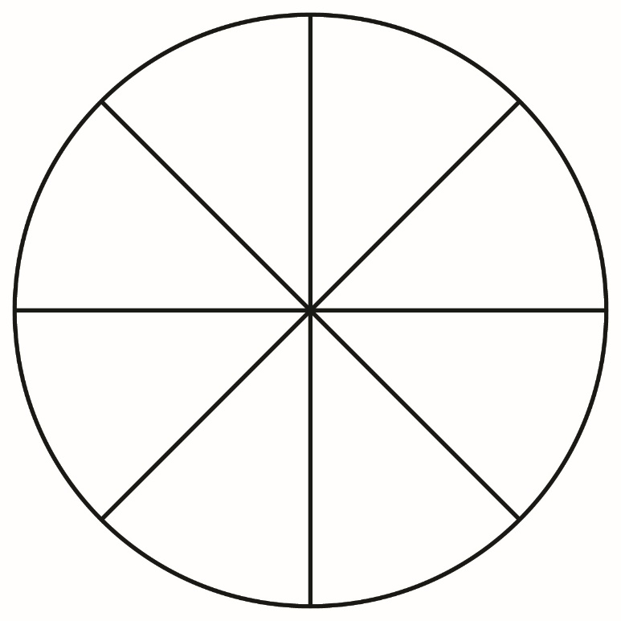
2. Arrange and glue the pieces inside the rectangle ABCD as shown.
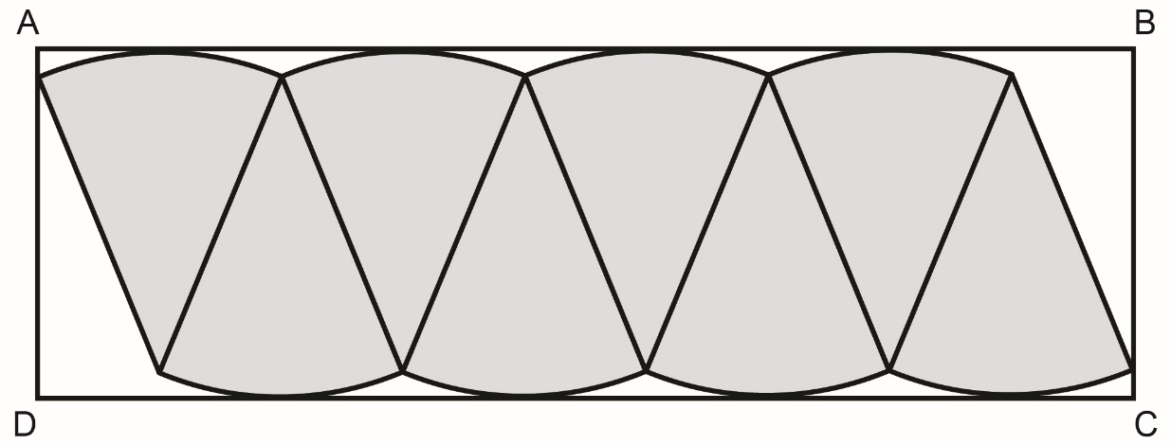

Explore the Area of a Circle 2 (cont’d)
Measurement
Unit 1 Line Master 8b

3. Determine the area of rectangle ABCD to approximate the area
of the circle.
4. The area of a rectangle relates to the measures of a circle:
Area of rectangle ABCD = AB × BC
= πr × r
= πr²
a) The length of the rectangle, AB, is approximately half
of the circumference, or πr. Explain why.
b) Why is the width of the rectangle, BC, the same as
the radius, r?

