Explore the Area of a Circle 1
Measurement
Unit 1 Line Master 7a

1. Construct a circle with a radius of 10–12 cm.
2. Fold the circle in quarters and cut along the folds.
3. Cut one of the quarters in half (2 equal parts) to create eighths.
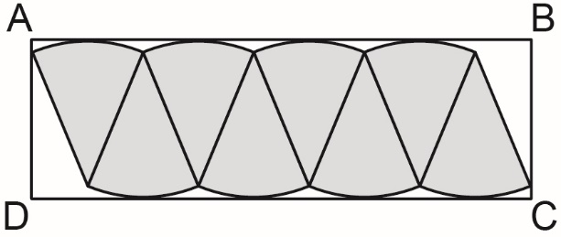
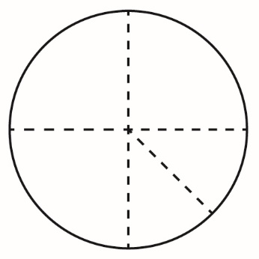
4. Arrange and glue the sections onto a piece of paper.
Then, draw rectangle ABCD around the shape as shown.
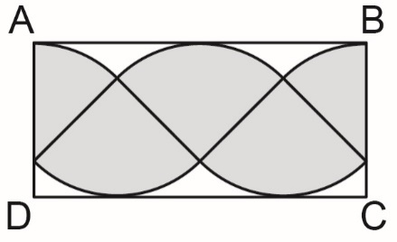
5. Determine the area of the rectangle to approximate the area
of the circle.
6. Construct a second circle congruent to the first.
7. Fold the circle in eighths and cut along the folds.
8. Arrange and glue the pieces onto a piece of paper.
Then, draw rectangle ABCD around the shape as shown.

Explore the Area of a Circle 1 (cont’d)
Measurement
Unit 1 Line Master 7b

9. Determine the area of rectangle ABCD to approximate the area
of the circle.
10. The area of a rectangle relates to the measures of a circle:
Area of rectangle ABCD = AB × BC
= πr × r
= πr²
a) The length of the rectangle, AB, is approximately half of the
circumference, or πr. Explain why.
b) Why is the width of the rectangle, BC, the same as
the radius, r?

