How to Use a Compass
Measurement
Unit 1 Line Master 2

Suppose you want to draw a circle with radius 5 cm.

Step 1: Place the pointer of the compass at 0 cm on a ruler,
then extend the tip of the pencil to 5 cm.

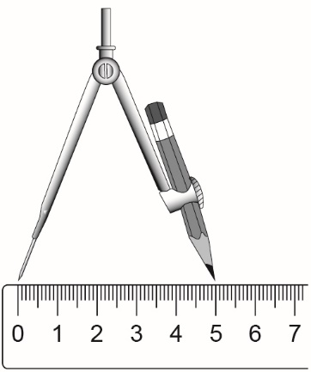

Step 2: Place the point of the compass at the centre of the circle.
Step 3: Draw the circle by turning the compass through 360º.

