Constructing Angle Bisectors
Measurement
Unit 1 Line Master 13

Method 1: Paper Folding
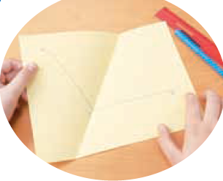
- Draw angle XYZ on a piece of paper.
- Fold the paper at Y so that XY lies along ZY.
- Open the paper and use a ruler to draw a
line segment along the fold.
Label the line segment YW.
- Use a protractor to measure the two angles
formed by the bisector. They should be equal.

Method 2: Mira
1. Draw angle XYZ.
2. Place the Mira so that the reflection of XY lies along ZY.
3. Draw a line segment along the edge of the Mira.
4. Verify the angle bisector.

Method 3: Compass
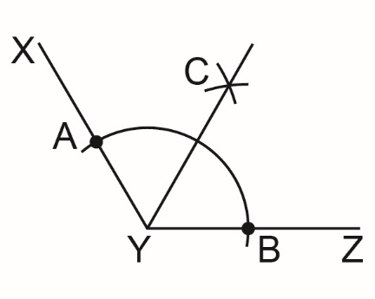
1. Draw angle XYZ.
2. Place the compass point on Y.
Draw an arc that intersects both arms
of the angle.
Label the intersection points A and B.
3. Do not change the distance between
the compass point and pencil tip.
Place the compass point on A. Draw an arc.
Then place the compass point on B.
Draw a second arc that intersects the first.
4. Label the intersection point C. Use a ruler to
draw line segment YC.
5. Verify that YC is the angle bisector of angle XYZ.

