Constructing Perpendicular
Bisectors
Measurement
Unit 1 Line Master 12a

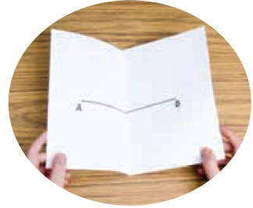
Method 1: Paper Folding
1. Draw a line segment AB.
2. Fold the paper so that point A lies
on point B.
3. Open the paper and use a ruler to draw
a line segment along the fold.
Label the intersection point P.
4. Use a ruler to measure the two parts of AB to check
they are equal. Use a protractor to measure the angles
to check each is 90°.

Method 2: Mira
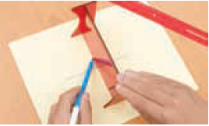
1. Draw a line segment AB.
2. Place the Mira so that the
reflection image of point A lies on
Point B.
3. Draw a line segment along the
edge of the Mira.
4. Verify the perpendicular bisector.

Constructing Perpendicular
Bisectors (cont’d)
Measurement
Unit 1 Line Master 12b

Method 3: Compass
1. Draw a line segment AB.
2. Set the compass so the distance between the compass and pencil points is greater than one-half the length of AB.
3. Place the compass point on A. Draw an arc. Do not change the distance between the compass point and pencil tip. Place the compass point on B. Draw a second arc that intersects the first.
3. Label the points of intersection C and D. Use a ruler to draw line segment CD.
4. Verify that CD is the perpendicular bisector of AB.
