Constructing Perpendicular Lines
Measurement
Unit 1 Line Master 11a

Method 1: Paper Folding
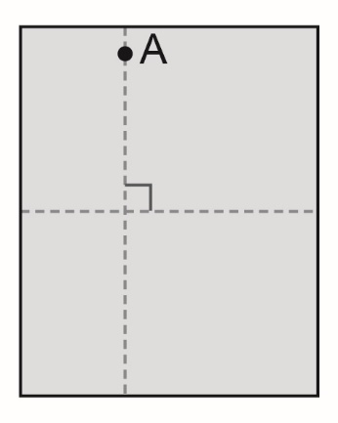
- Fold a piece of paper in half. Open the paper
and draw a line segment along the fold.
- Mark point A above the line.
- Fold the paper at point A so that
the line segment is folded onto itself.
- Open the paper. Draw a line segment
along the fold. This creates a line segment
perpendicular to the starting line segment.
Method 2: Protractor
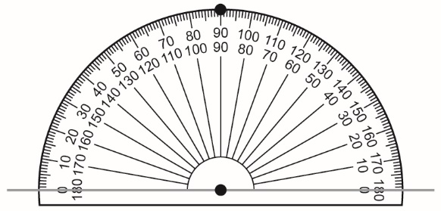
1. Draw a line segment. Mark a point
on the line segment.
2. Place the centre of the protractor
on the point.
3. Mark a point at 90°.
4. Join the two marks to draw a line segment perpendicular
to the starting line segment.

Constructing Perpendicular Lines
(cont’d)
Measurement
Unit 1 Line Master 11b

Method 3: Compass
1. Draw a line segment. Mark point A on the line segment.
2. Place the compass point on A. Draw an arc below the line
segment that intersects it twice. Label the intersection
points B and C.
3. Place the compass point on B. Open the compass so that
the distance between the compass point and the pencil tip is longer than the radius AB. Draw an arc above
the line segment. Then place the compass point on C and draw
another arc so that these arcs intersect. Label that point D.
4. Draw a line through points A and D. Line segment AD is
perpendicular to the starting line segment.
