Constructing Parallel Lines
Measurement
Unit 1 Line Master 10a

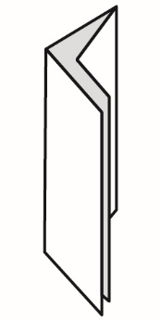
Method 1: Paper Folding
1. Fold a piece of paper in half and
then in half again.
2. Open the paper and use a ruler to draw
3 parallel line segments along the folds.

Method 2: Protractor
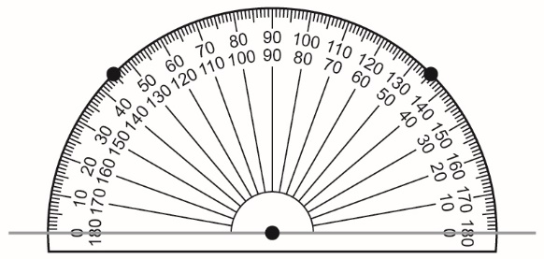
1. Draw a line segment.
Mark a point on the line segment.
2. Place the centre of the protractor
on the point.
3. Mark a point at each 45° mark.
4. Join the two marks to draw a line segment
parallel to the starting line segment.
Method 3: Compass
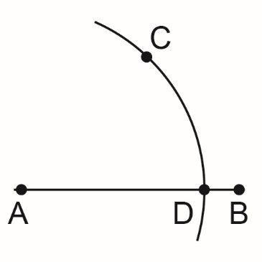
1. Draw line segment AB. Mark point C
above the line segment.
2. Place the compass point on A.
Set the compass so the pencil point
is on C. Draw an arc through point C
that intersects line segment AB.
Label that point D.

Constructing Parallel Lines (cont’d)
Measurement
Unit 1 Line Master 10b

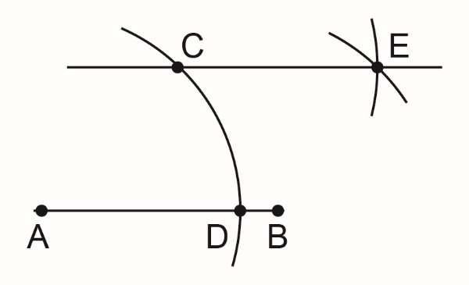
3. Do not change the distance between
the compass point and pencil tip.
With the compass point on point C,
draw an arc. Then, place the compass
point on point D. Draw another arc so that
these arcs intersect. Label that point E.
4. Draw a line through points C and E.
Line segment CE is parallel to line segment AB.

