Exploring Tessellations
Identifies a tessellation and describes its transformations  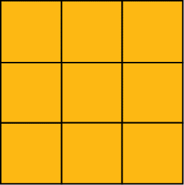  This is a tessellation because there are no gaps or overlaps.  The square is translated/reflected/ rotated. | Explains why a pattern does not show a tessellation  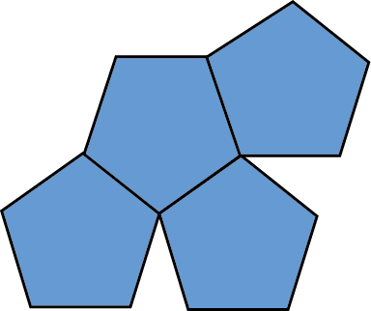  This pattern does not show a tessellation because there are gaps in it. | Draws a tessellation of a shape and describes the transformation(s)  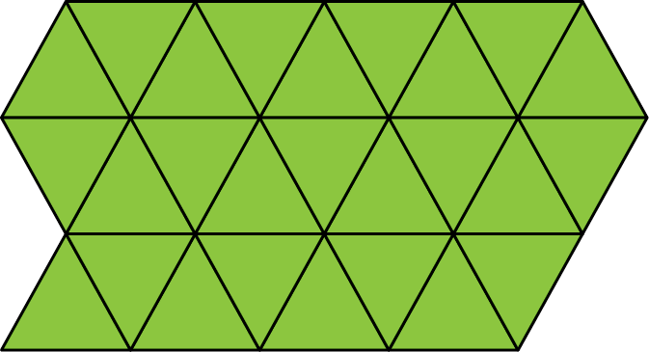  The triangle is reflected/translated/ rotated 60⁰ clockwise about a vertex. | Identifies 2 shapes that tessellate, then draws the tessellation  The hexagon and trapezoid tessellate because 2 trapezoids are congruent to 1 hexagon.  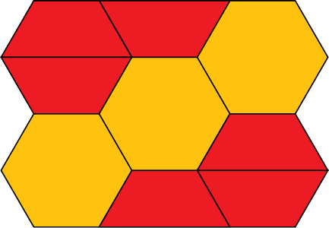
Observations/Documentation

