Combining Transformations
Identifies a transformation in different ways  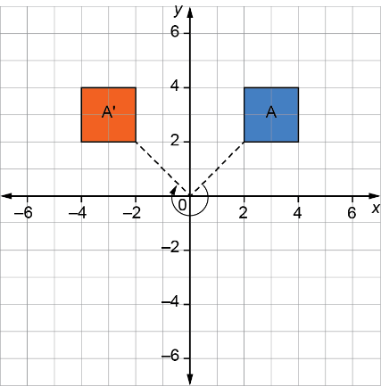  Square A’ is the image of square A after:  a reflection in the y-axis;  a translation of 6 units left;  a rotation of 270⁰ counterclockwise about the origin O | Identifies 2 consecutive transformations  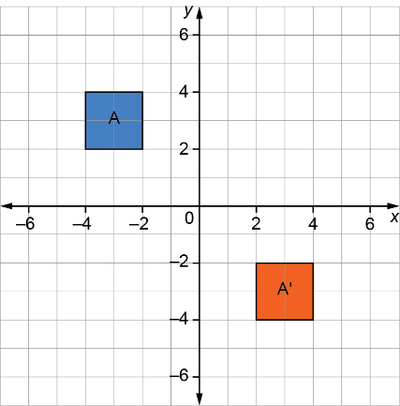  Square A’ is the image of square A after a reflection in the y-axis, then a translation 6 units down. | Performs 3 or more consecutive transformations  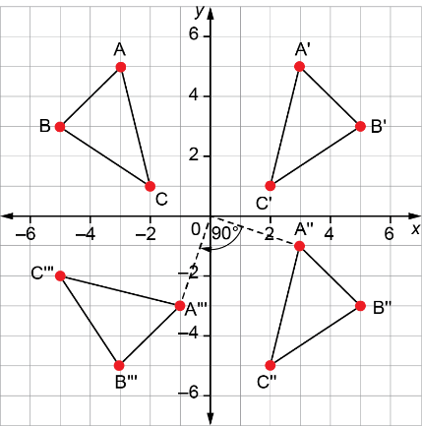  ΔA’B’C’ is the image of  ΔABC after a reflection in the y-axis.  ΔA’’B’’C’’ is the image of  ΔA’B’C’ after a translation 6 units down.  ΔA’’’B’’’C’’ is the image of ΔA’’B’’C’’ after a rotation of 90⁰ clockwise about O. | Identifies different types of transformations  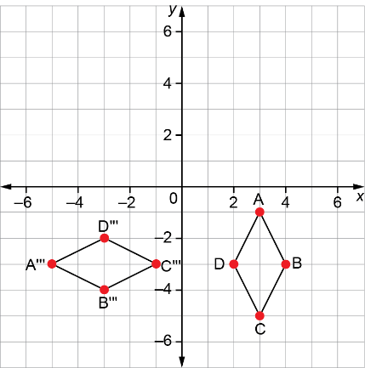  ABCD is rotated 90⁰ counterclockwise about the origin to Quadrant 1, then translated 6 units left to Quadrant 2, then reflected in the x-axis to the final image A’’’B’’’C’’’D’’’ in Quadrant 4.
Observations/Documentation

