Reflecting and Rotating 2-D Shapes on a Cartesian Plane
Reflects a point in the  x-axis, in the y-axis, and in a diagonal line  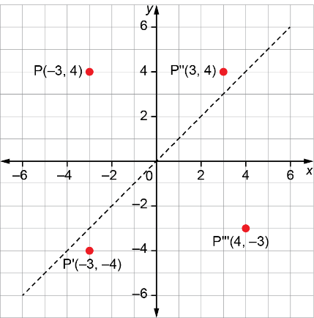  P’ is the image of P after a reflection in the x-axis.  P’’ is the image of P after a reflection in the y-axis.  P’’’ is the image of P after a reflection in a diagonal line through the origin. | Reflects a shape and relates the vertices of each image to the shape  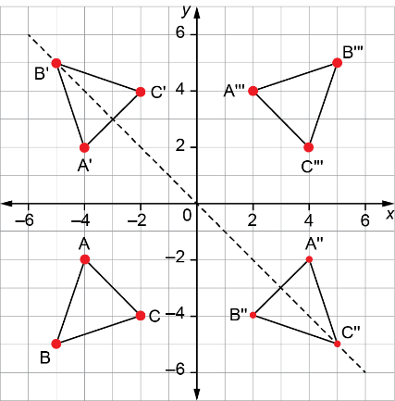  ΔA’B’C’ is the image of ΔABC after a reflection in the x-axis.  ΔA’’B’’C’’ is the image of ΔABC after a reflection in the y-axis.  ΔA’’’B’’’C’’’ is the image of ΔABC after a reflection in a diagonal line through the origin.  Each vertex of the image is the same distance from the reflection line as its corresponding vertex on the shape. | Rotates a shape about a vertex  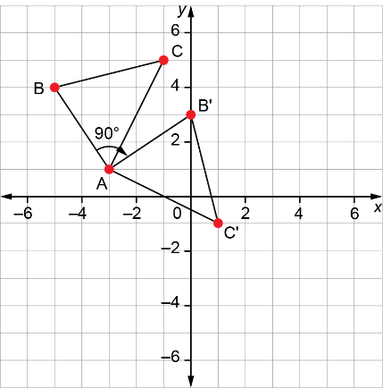  ΔAB’C’ is the image of ΔABC after a clockwise rotation of 90⁰ about vertex A. | Rotates a shape about a point outside the shape  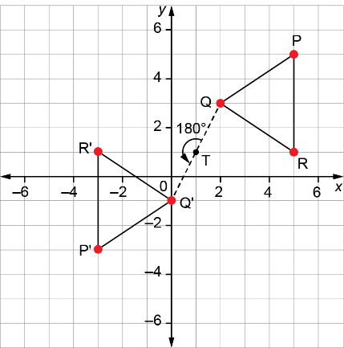  ΔP’Q’R’ is the image of ΔPQR after a rotation of 180⁰ about point T.

Observations/Documentation

