Translating 2-D Shapes on a Cartesian Plane
Plots points in 4 quadrants of a Cartesian plane  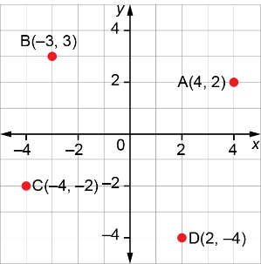 | Translates points in 4 quadrants of a Cartesian plane  I translated point A  10 units right, 5 units down to image point A’.  I translated point B  5 units left, 7 units down to image point B’.  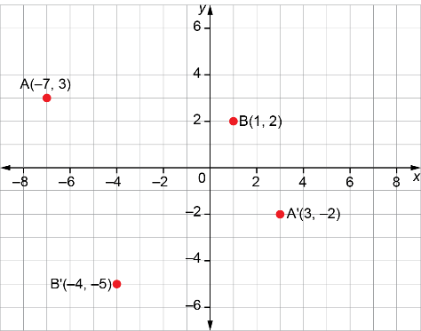 | Translates a shape on a Cartesian plane and identifies coordinates of the image  I translated ΔPQR  6 units left, 3 units up to image ΔP’Q’R’.  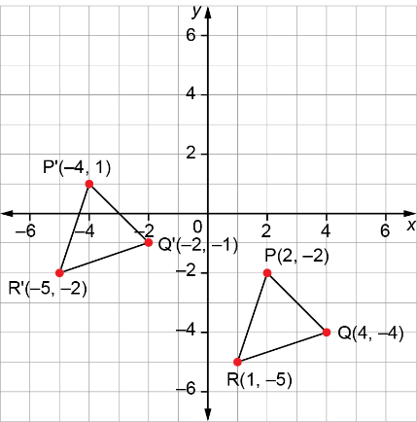 | Identifies the translation given a shape and its image on a Cartesian plane  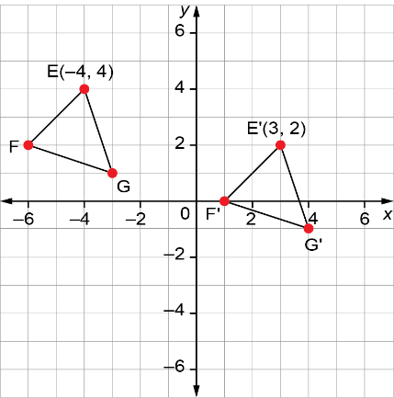  Each vertex on ΔEFG was translated 7 units right, 2 units down to image ΔE’F’G’, so this is the translation for ΔEFG.
Observations/Documentation

