Exploring the Cartesian Plane
Plots points in the first quadrant  of a Cartesian plane  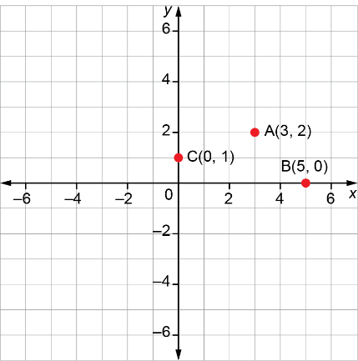 | Writes the coordinates of points in all 4 quadrants of a Cartesian plane  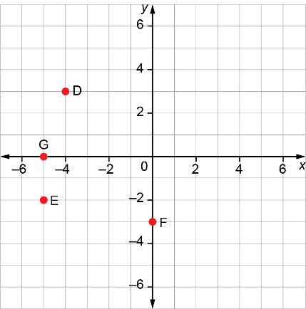  D(–4, 3); E(–5, –2);  F(0, –3); G(–5, 0) | Plots points in all 4 quadrants  of a Cartesian plane  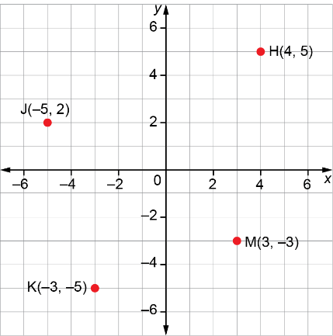 | Plots points in all 4 quadrants with axes for which the scale is not  1 square represents 1 unit  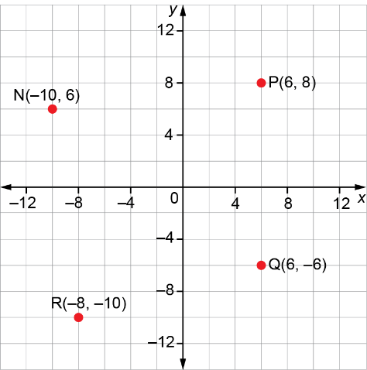
Observations/Documentation

