Shapes on the Move
Geometry
Unit 1 Line Master 8a

• Look at the Transformation card you have been given.
• On Grid 1, draw a shape.
Label it Shape A.
• Perform the first transformation.
Label it Image A′.
• Perform the second transformation on image A′.
Label it Image A″.
• On Grid 2, draw Shape A and Image A″.
• Trade your Grid 2 with another pair of students.
Identify the two transformations performed on their grid.
Grid 1
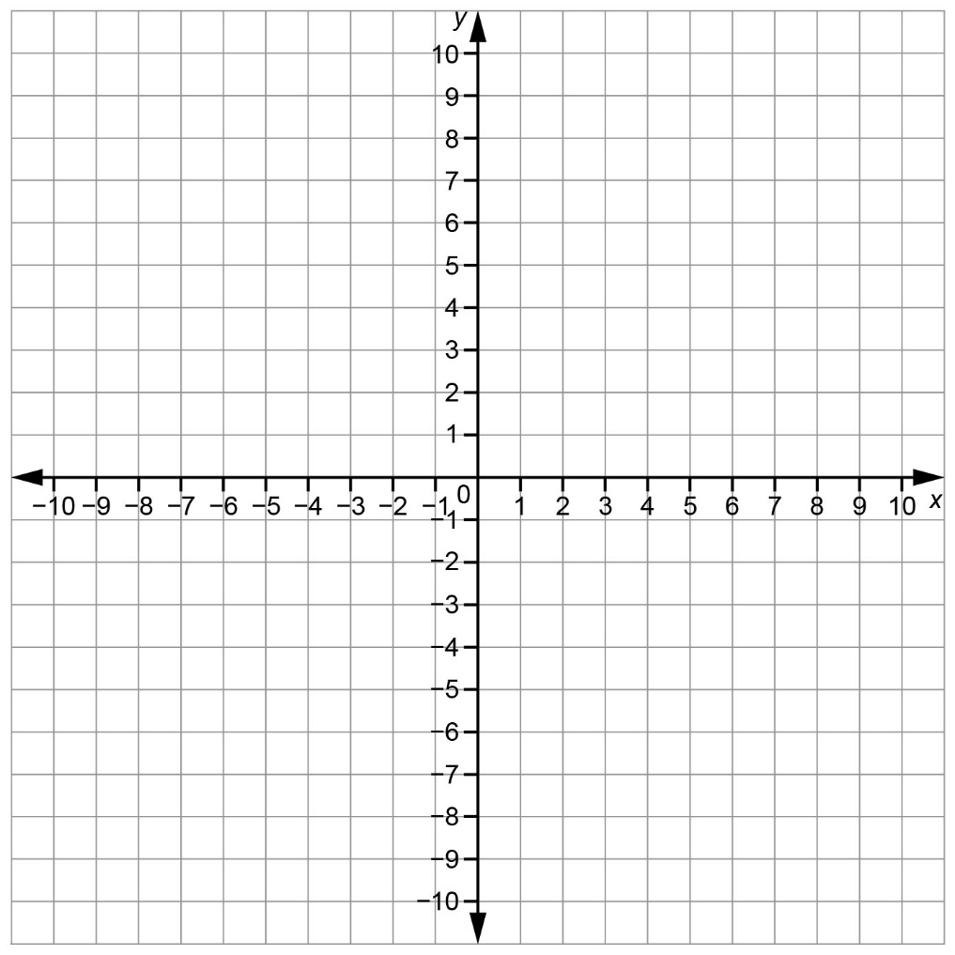
Shapes on the Move (cont’d)
Geometry
Unit 1 Line Master 8b

Grid 2

