Rotating a Shape about a Vertex
Geometry
Unit 1 Line Master 6a

Record the coordinates for two vertices of each shape
and their images in the table below.
1. Draw Shape 1 using a maximum of 6 points.
2. Choose a vertex.
Rotate Shape 1 90° clockwise about the vertex.
Label the rotation image as Shape 2.
3. Repeat Step 2 for a rotation of 180° about the same vertex.
Label the rotation image of Shape 1 as Shape 3.
4. Repeat Step 3 for a rotation of 270° clockwise about
the same vertex.
Label the rotation image of Shape 1 as Shape 4.
5. Describe how each image is related to the original shape.
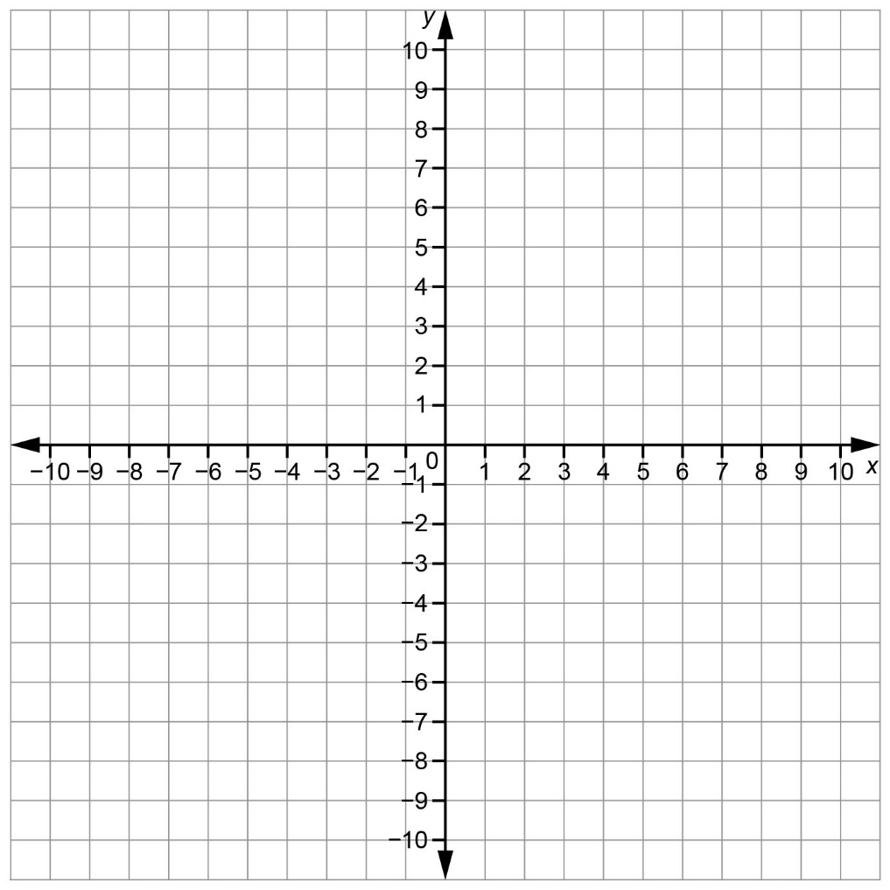
Rotating a Shape about a Vertex (cont’d)
Geometry
Unit 1 Line Master 6b

Rotation Image Shape 2
Description | Coordinates of Vertices of  Shape 1 | Coordinates of Vertices of Image Shape 2
Rotation Image Shape 3
Description | Coordinates of Vertices of  Shape 1 | Coordinates of Vertices of Image Shape 3
Rotation Image Shape 4
Description | Coordinates of Vertices of  Shape 1 | Coordinates of Vertices of Image Shape 4

