Reflecting a Shape
Geometry
Unit 1 Line Master 5a

Record the coordinates for two vertices of each shape
and their images in the table below.
1. Draw Shape 1 using a maximum of 6 points.
2. Choose a horizontal line of reflection.
Reflect Shape 1 in the line. Label the reflection image
as Shape 2.
3. Repeat Step 2 for a vertical line of reflection.
Label the reflection image of Shape 1 as Shape 3.
4. Repeat Step 3 for a diagonal line of reflection through the origin.
Label the reflection image of Shape 4.
5. Describe how each image is related to the original shape.
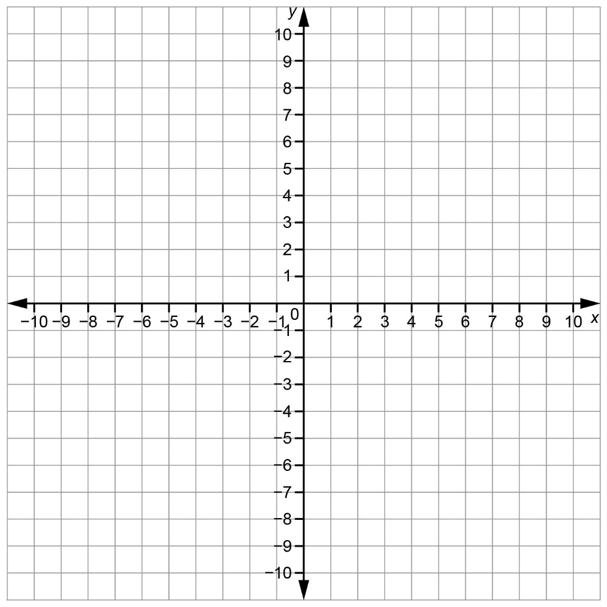
Reflecting a Shape (cont’d)
Geometry
Unit 1 Line Master 5b

Reflection Image Shape 2
Description | Coordinates of Vertices of Shape 1 | Coordinates of Vertices of Image Shape 2
Reflection Image Shape 3
Description | Coordinates of Vertices of Shape 1 | Coordinates of Vertices of Image Shape 3
Reflection Image Shape 4
Description | Coordinates of Vertices of  Shape 1 | Coordinates of Vertices of Image Shape 4

