Fill the Cartesian Plane
Geometry
Unit 1 Line Master 4a

- On the grid, draw and shade a rectangle made of two
grid squares. Label the vertices of the rectangle ABCD.
Record the coordinates of the vertices in the table.
- Take turns. Roll two number cubes. Use the numbers
on the cubes to translate rectangle ABCD. You decide
the directions of the translation. Translate and shade
the image rectangle.
- Record coordinates for each vertex of the image in the table using prime notation.
- Continue until rectangle ABCD can no longer be translated to unshaded squares. The person who makes the final translation wins.

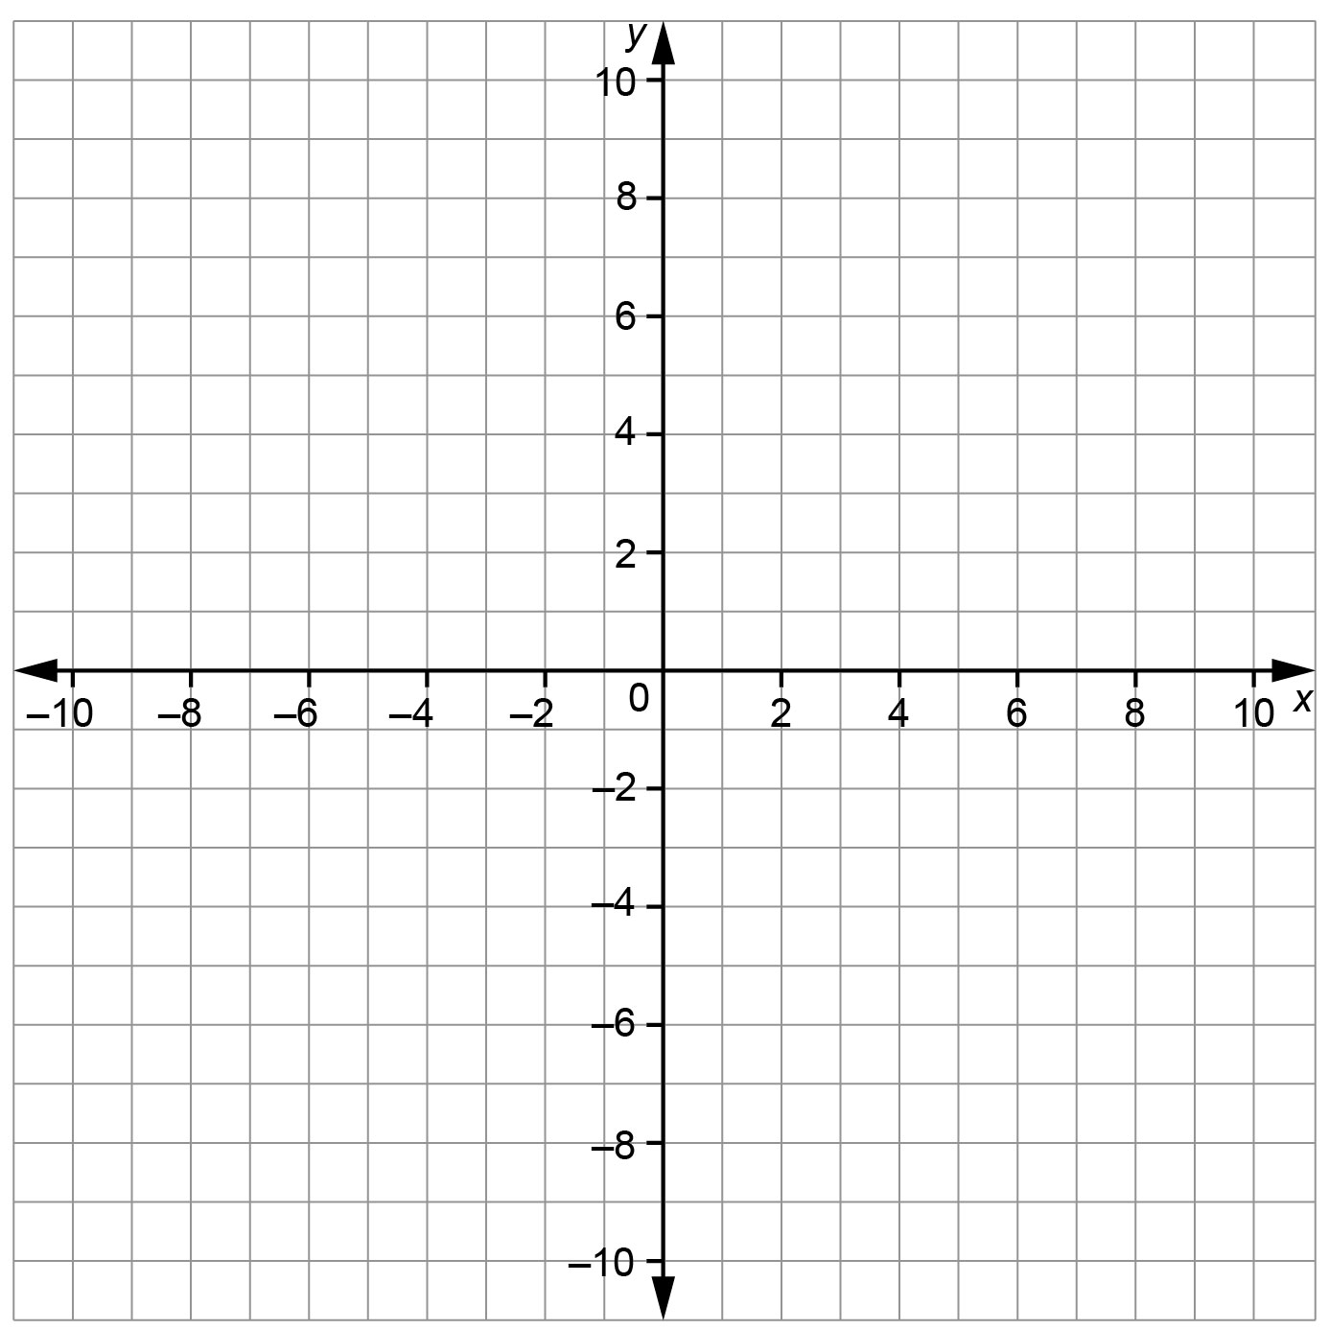
Fill the Cartesian Plane (cont’d)
Geometry
Unit 1 Line Master 4b

Coordinates of the vertices of rectangle ABCD | Translations |  | Coordinates of the vertices of image rectangle A’B’C’D’
 | Horizontal  Left/right | Vertical  Up/down

Fill the Cartesian Plane (cont’d)
Geometry
Unit 1 Line Master 4c

Coordinates of the vertices of rectangle ABCD | Translations |  | Coordinates of the vertices of image rectangle A’B’C’D’
 | Horizontal  Left/right | Vertical  Up/down

Fill the Cartesian Plane (cont’d)
Geometry
Unit 1 Line Master 4d

Coordinates of the vertices of rectangle ABCD | Translations |  | Coordinates of the vertices of image rectangle A’B’C’D’
 | Horizontal  Left/right | Vertical  Up/down

