Where are My Watercraft?
Geometry
Unit 1 Line Master 1

Place at least one boat in each quadrant and part of the 5th boat must lie on an axis.
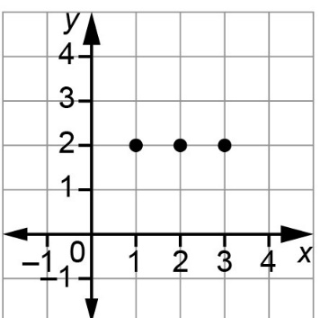
To plot a watercraft,
make sure each point is on a lattice point, e.g., canoe at (1, 2), (2, 2), (3, 2)
All watercraft must be placed either vertically
or horizontally.

Pontoon Boat (5 points)
Fishing Boat (4 points)
Speed Boat (4 points)
Canoe (3 points)
Paddle Board (2 points)

Take turns asking each other whether a point lands on one
of the watercraft.
My Watercraft | Opponent’s Watercraft
