Writing Experimental Probabilities
Identifies and counts the desired outcomes in a probability experiment  Tossing two heads  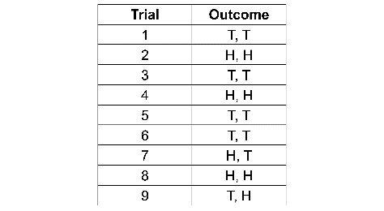  The outcome H, H occurred 3 times. | Represents a probability as a fraction  As a fraction, the experimental probability of H, H is three out of  line, or $\frac{3}{9}$. | Converts a fraction to a decimal  $\frac{3}{9}$ is the same as $\frac{1}{3}$, which is 0.333  3…  As a decimal, the experimental probability of H, H is approximately 0.333 or $0.\overline{3}$. | Expresses a probability as a percent, and a ratio  $\frac{1}{3}$= 0.333… ≈ 33% ≈ 1 :3  As a percent, the experimental probability of H, H is approximately 33%.  As a ratio, the experimental probability of H, H is 3:9 = 1:3.
Observations/Documentation

