Exploring Circle Graphs
Understands that a circle graph represents data that are parts of one whole  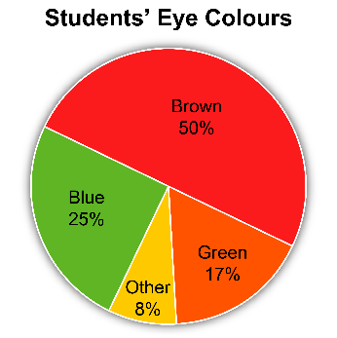  The sum of the percents is 100. This represents all the students who were surveyed. | Interprets a circle graph to answer questions  120 students were surveyed.  The number of students with blue eyes is:  25% of 120  = 0.25 × 120  = 30  30 students have blue eyes. | Determines the central angle for a circle graph  25% of the people surveyed chose chocolate as their favourite ice cream flavour.  To show this on a circle graph, what would the central angle be?  25% of 360°  = 0.25 × 360°  = 90° | Constructs a circle graph using the central angle determined for each piece of data  Here are data about favourite  ice cream flavours.  Chocolate, C: 25%  Strawberry, S: 40%  Vanilla, V: 20%  Other, O:15%  Central angles:  C: 25% of 360° = 90°  S: 40% of 360° = 144°  V: 20% of 360° = 72°  O: 15% of 360° = 54°  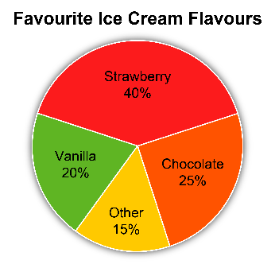
Observations/Documentation

